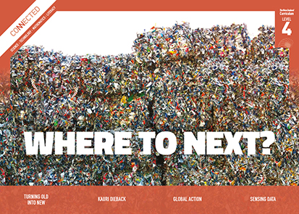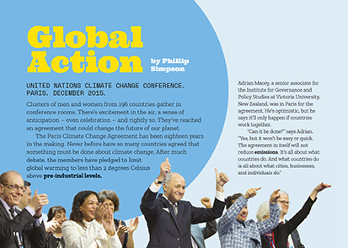
Connected
Level 4
2017

Global Action
by Phillip Simpson

Overview
This detailed article looks at the science and politics of climate change. It examines how scientists use computer modelling to predict the impact of climate change, how different countries need to work together to combat the effects, and the focus in New Zealand on reducing the release of methane and nitrous oxide into the atmosphere in agriculture.
A Google Slides version of this article is available at www.connected.tki.org.nz. This text also has additional digital content, which is available online at www.connected.tki.org.nz

Curriculum contexts

SCIENCE: Nature of Science: Participating and contributing  Level 4 – Students will:  - use their growing science knowledge when considering issues of concern to them  - explore various aspects of an issue and make decisions about possible actions. | Key Nature of Science ideas  When we engage scientifically with an issue, we:  - Look for a range of scientific information that relates to the issue  - Check that information we use is from a trustworthy source  - Consider the reliability and validity of the evidence  - Decide if and how to respond to the issue, justifying our decisions based on evidence and/or reliable scientific information  - Monitor the effects of any actions we take.
SCIENCE: Planet Earth and Beyond: Interacting systems  Level 4 – Students will investigate the water cycle and its effect on climate, landforms, and life.  SCIENCE: Living World: Ecology  Level 4 – Students will explain how living things are suited to their particular habitat and how they respond to environmental changes, both natural and human-induced. | Key science ideas  - Greenhouse gases in the atmosphere help stop the heat absorbed by Earth from the sun being lost into space.  - Human activity, such as burning fossil fuels and intensive farming, have increased the amount of these gases so temperatures on Earth are getting warmer.  - Higher temperatures are causing ice sheets and glaciers to melt more rapidly, contributing to a rising sea level.
ENGLISH: Reading  Level 4 – Ideas: Students will show an increasing understanding of ideas within, across, and beyond texts. | Indicators  - Makes meaning of increasingly complex texts by identifying and understanding main and subsidiary ideas and the links between them.  - Makes connections by thinking about underlying ideas within and between texts from a range of contexts.  - Recognises that there may be more than one reading available within a text.  - Makes and supports inferences from texts with increasing independence.

The New Zealand Curriculum

Science capability: engage with science

Capability overview
This capability requires students to use the other capabilities to engage with science in real-life contexts. It requires students to take an interest in science issues, participate in discussions about science, and at times, take action.  The dimensions of this capability can be demonstrated when students engage in discussions about science issues, including those in the media. If these discussions build on the ideas of others, emphasise logical connections, and draw reasonable conclusions, and if the speakers make the evidence behind their claims explicit, then students have the opportunity to practise playing the “game of science” (Resnick, Michaels, & O’Connor, 2010). | This allows them to deepen their understanding of what science is.  Students also need opportunities to be actively engaged in exploring real-life science issues that are relevant to them and their communities. This could involve building new knowledge with others and taking action to address local or global concerns.

More about the capability

The capability in action
Real-life science issues:  - may involve a mix of scientific issues and forms of social-science inquiry, including values and ethics  - provide opportunities to build awareness of which questions can be investigated and which questions science does not answer  - provide opportunities to see science as tentative, that is, developing over time as evidence is gathered or reinterpreted  - provide experiences of uncertainty where there is no clear explanation or solution  - allow students to gather and interpret data about a local situation or to critique a range of evidence and claims  - may generate a range of student views, responses, and possible actions.  Students  Students should have opportunities to:  - take an interest in a range of scientific issues  - participate in discussions about scientific issues  - use their developing capabilities of gathering and interpreting data, using and critiquing evidence, and interpreting representations to create a viewpoint, response, or action on scientific issues.  Teachers  Teachers can:  - establish a science classroom culture by:  - taking a personal interest in scientific issues, modelling questions, explicitly critiquing evidence, and seeking further evidence | - maximising everyday opportunities to introduce learning conversations that engage students with science and scientific issues  - helping their students to notice and investigate science in their everyday surroundings, such as ice on a puddle, the health of a local stream or river, or what happens as materials are mixed or heated  - listening to and discussing socio-scientific items in the news  - exploring locally relevant and contentious scientific issues, such as irrigation, intensive farming, or the effects of climate change  - support students to identify scientific aspects of an issue  - provide a range of resources and investigation opportunities pertaining to scientific issues that require students to use a range of science capabilities  - encourage students to seek and critically evaluate a range of scientific evidence, opinions, and actions from a variety of sources about an issue  - manage with sensitivity situations where students and their whānau may hold differing and strongly held opinions about a science-related issue, such as irrigation  - support students to identify and take appropriate actions in response to science-related issues.  It is important that students are empowered to be hopeful and see opportunities for positive action and change when considering local and global issues.

More activities to develop the capability

Meeting the literacy challenges

The main literacy demands of this text are around the large amount of complex ideas and information. Students will need to combine information from two infographics, one demonstrating the process of global warming and one explaining a solution for reducing livestock emissions, with explanations in the text to understand the science ideas about global action to limit earth’s temperature increases.  In addition, students will need to integrate information from a graph showing the rate of temperature rises over the past 135 years with a computer-generated model to understand how scientists gather, use, and interpret information to predict the future effects of global warming. | There are a number of unfamiliar words related to the science of climate change, as well as academic language associated with scientists’ investigative processes.  The following instructional strategies will support students to understand, respond to, and think critically about the information and ideas in the text.  You may wish to use shared or guided reading, or a mixture of both, depending on your students’ reading expertise and background knowledge.  After reading the text, support students to explore the activities outlined in the following pages.

INSTRUCTIONAL STRATEGIES

Finding the main ideas  Have the students read the title and first page to find out what it is about. ASK QUESTIONS to help them make connections to their prior knowledge.  What do you know about climate change? What is causing it?  What does “global action” mean?  Why was the Paris Climate Change Agreement so important? What evidence supports this?  What still needs to be achieved?  EXPLAIN that in this text there is a lot of information on a very important subject. There are at least three major themes. Ask them to SCAN the headings and images to predict what they are. Help them to notice the following three themes:  What climate change is and how it happens  How climate modelling works  How scientists are trying to reduce emissions from New Zealand agriculture.  Have students write each theme as a heading in their notebooks. Ask them to SKIM the text to find where they are covered and note the page numbers under the headings.  As the students read on, ASK QUESTIONS to prompt discussion and help them make meaning of the text.  What evidence and data are used to predict the consequences of global warming?  What do scientists agree are the causes of global warming? What are the effects?  What information in the text helped you to form your answer?  What inferences can you make about pre-industrial levels of greenhouse gas?  What does “to do our part” mean? Do you agree that New Zealand has a responsibility to prevent global warming?  What does it mean for New Zealand that most of our emissions come from agriculture? What evidence does the text provide to support this? What did you already know about this (for example, from the media)? | Have students reread the text and work in pairs to write brief summaries of each of the three themes. The summaries should be two or three sentences long, focusing on the main ideas.  There is a lot of detail in this article. What are the messages the author wants us to understand? How does the organisation of the text help you to find the main ideas and the supporting details? What would you say if you were explaining to another person what the article is about?  Have each pair share their summary sentences with another pair. Prompt reflection on how writing and talking help scientists to clarify and evolve their thinking.  Have you focused on the same ideas?  Now that you’ve seen what other students have highlighted, do you still think you focused on the most important ideas? It’s okay to change your mind! Remember, a good scientist is always open to change if that’s what the evidence says to do.  How did the process of talking and writing about the main ideas help you to understand them?  As a class, create a final summary to clarify the main ideas.  Using design features for deeper understanding  During the second reading, have the students create diagrams to represent their understandings of different concepts. This will provide an opportunity for them to deepen their understandings as they re-engage with key ideas, discuss and negotiate their interpretations of those ideas, and explore different ways of representing ideas about science. Students should draw their diagrams independently then compare them with a partner, using the following process.  - Have pairs of students sketch their own versions of the diagram on page 19, omitting the words. Give each pair a copy of the words. TELL them to cut the words up and decide where they belong on the diagram. Have them take turns explaining to each other what their diagrams show. Finally, have them compare their diagrams with the original, checking that they have correctly understood how heat energy is transferred through the environment.

Meeting the literacy challenges

- Have students use the model and information from the text (pages 20–21) to create a diagram that SUMMARISES the effects of greenhouse emissions. They should use this to EXPLAIN what they have learned to their partner and check each other’s understandings.  - Have students draw the nitrogen cycle using the information in the “We need to talk about nitrogen” section on page 22. They should use this to EXPLAIN the cycle to their partner and check each other’s understandings. | Extending the learning  The students could select a topic from the article to investigate further and explore imaginative ways of conveying this information to their peers. This might include:  - designing infographics with more information about Earth’s atmosphere or how livestock contribute to greenhouse gases  - creating a graduated diagram detailing the future effects of rising temperatures.

Reading standard: by the end of year 8
The Literacy Learning Progressions
Effective Literacy Practice: years 5–8

TEACHER SUPPORT
Students explore various aspects of an issue and make decisions about possible actions.  Students participate in discussions about scientific issues. | 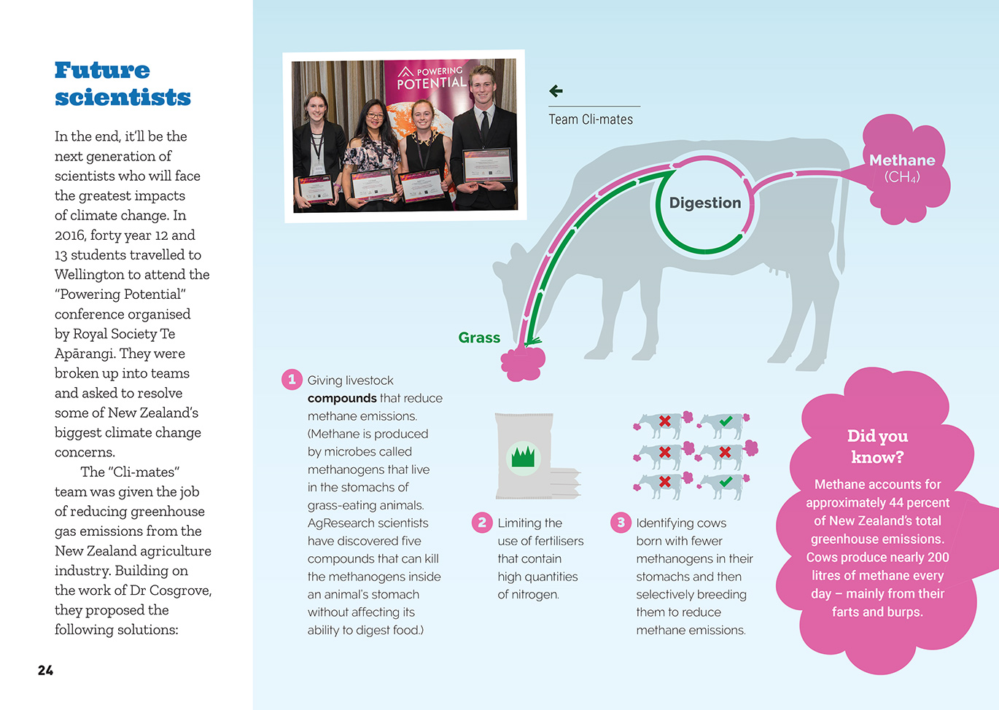  Scientists decide if and how to respond to the issue, justifying decisions based on evidence and/or reliable scientific information.  Human activity, such as intensive farming, have increased the amount of greenhouse gases.

Learning activities – Exploring the science
The following activities and suggestions are designed as a guide for supporting students to explore and develop understandings about the science capability “engage with science”. Some activities focus directly on the science capability. Other activities extend student content knowledge across the learning areas. Adapt these activities to support your students’ learning needs.

Activity 1 – What can we do?
Talk about the concept of global action.
People talk about “thinking globally and acting locally”. What does this mean?
Have the students find out more about New Zealand’s pledge to reduce global temperatures and the progress made since 2005. Create a timeline on the wall for the students to record and share their findings.
Have the students read the Curious Minds story “How can we handle climate change?” to help them recognise that young people can and should play a role in addressing this issue.
Challenge the students:
What can we do at an individual level?
What can we do in our school, homes, and community?
Discuss and agree on your next steps as a class. The rest of this activity is made up of suggested steps, but it is likely that your students will have lots of ideas.
Students could investigate possible changes at school. For example, the students could investigate the amount of food waste the school sends to the tip each year.
The food waste decomposes and produces methane gas. What do we know about how this happens? How could we reduce the amount of food waste our school generates?
Another approach is to investigate and promote small changes individuals can make. Students will need to think about how to communicate science ideas in ways that inform people and motivate them to change. The students could:
make short clips for YouTube
design and make pamphlets
write and perform plays.
Whichever approach the students take, remind them of the importance of:
monitoring the impact of their actions
using what they learn from their monitoring to consider how their actions could be improved
capturing and presenting their learning so they and others can gain from it.

Activity 2 – What happens when water warms up?
Have the students conduct the following experiment to investigate what happens when water heats up.
1. Take the lid of a PET plastic bottle, and make a hole in it big enough for a straw.
2. Fit a straw through the hole until the lid is about halfway along the straw.
3. Use Blu Tack to seal the gaps between the straw and the lid.
4. Fill the bottle to the very top with coloured water.
5. Screw on the lid fitted with the straw.
6. Place the bottle near a heat source (in the sun, under a heat lamp, or in a bowl of hot water).
7. Observe what happens to the level of water in the straw as the water slowly warms up.
8. Discuss:
  - Has any more water been added?
  - Why is water moving up the straw?
  - If this amount of water takes up this much more room as it warms, what may happen as oceans warm?
  - What else happens as water warms?
Have the students design an investigation to measure and compare evaporation rates of hot, warm, and cold water. For example, they could measure the temperature changes of three water samples:
one left in a hot place at regular intervals
one with ice added to it at regular intervals
one neutral sample (no heat, no ice).
Discuss:
Do the three water samples evaporate at the same rate? How is this like the ocean under global warming?
Look at a world topographical map that shows icy regions and the oceans. What do you think will be happening to ocean temperatures in different places on Earth?
Prompt the students to consider the implications of these investigations.
How do these investigations help us understand the complex factors that affect ocean temperatures and sea level rise?
What other complexities may affect predictions? What questions come to your mind?

Extending the learning
Use the final discussion to determine the next steps for learning. Where do the students’ interests lead? For example, they may want to find out about the causes and effects of ocean currents or what the historical records tell us about changes in sea levels over millennia.

Learning activities – Exploring the science

Activity 3 – What is happening to rainfall?  Have the students reread the text about computer modelling and the predictions that are coming from it. With this in mind, have them examine Statistics New Zealand’s maps showing average rainfall from 1972–2013.  How do you think these maps might change in the next forty years? What makes you think so?  Have the students look at the Ministry for the Environment’s predictions for how temperatures and rainfall may change. Clarify that these predictions are also based on scientific modelling.  How will our region be affected if carbon emissions around the world are reduced?  What will happen if we don’t reduce emissions? How will it affect humanity? How will it affect our fellow creatures?  Have students use a summary chart (see example below) to record what they know about this model. Then have them use the resource links to find out about other climate models. This task could be shared around different groups, with the information collated in one place. | Name of the model How it is created What it shows  The students could create their own models to support their understanding of the effects of climate change and global warming. Alternatively, they could participate in Climateprediction.net, described as the world’s largest climate modelling experiment.  Extending the learning  Some students may like to go further and explore why there are different computer models for climate change.

RESOURCE LINKS

Building Science Concepts  Book 29, Solar Energy: Sun Power on Earth  Connected  “Captured in Ice”, Connected 2017, level 3, Mahi Tahi http://instructionalseries.tki.org.nz/Instructional-Series/Connected  “The Ozone Hole”, Connected 3, 2008.  Science Learning Hub  Antarctica and global climate change: www.sciencelearn.org.nz/resources/421-antarctica-and-global-climate-change  Climate change, science, and controversy: www.sciencelearn.org.nz/resources/2212-climate-change-science-and-controversy  Climate action: www.sciencelearn.org.nz/resources/2215-climate-action  Disappearing glaciers: www.sciencelearn.org.nz/resources/2213-disappearing-glaciers  Climate change – a wicked problem for classroom inquiry resource: www.sciencelearn.org.nz/resources/2229-climate-change-a-wicked-problem-for-classroom-inquiry  Scientific modelling: www.sciencelearn.org.nz/resources/575-scientific-modelling  Climate models: www.sciencelearn.org.nz/resources/2232-climate-models  Climate change, melting ice, and sea level rise: www.sciencelearn.org.nz/resources/2277-climate-change-melting-ice-and-sea-level-rise  Investigating sea level rise (activity): www.sciencelearn.org.nz/resources/2278-investigating-sea-level-rise | Carbon dioxide emissions calculator: www.sciencelearn.org.nz/resources/1588-carbon-dioxide-emissions-calculator  Melting glacial ice (activity): www.sciencelearn.org.nz/resources/2279-melting-glacial-ice  Greenhouse effect: www.sciencelearn.org.nz/resources/1004-greenhouse-effect  Greenhouse simulation: www.sciencelearn.org.nz/resources/1589-greenhouse-simulation  Energy sources through time – timeline: www.sciencelearn.org.nz/resources/1636-energy-sources-through-time-timeline  Public acceptance of using genetically modified bacteria to reduce methane emissions of sheep: www.sciencelearn.org.nz/resources/2177-public-acceptance-of-using-genetically-modified-bacteria-to-reduce-methane-emissions-of-sheep  Carbon dioxide and climate: www.sciencelearn.org.nz/resources/2231-carbon-dioxide-and-climate  Inhibiting nitrous oxide emissions: www.sciencelearn.org.nz/resources/922-inhibiting-nitrous-oxide-emissions  The nitrogen cycle: www.sciencelearn.org.nz/resources/960-the-nitrogen-cycle  Thin Ice in the classroom: www.sciencelearn.org.nz/resources/2233-thin-ice-in-the-classroom

Learning activities – Exploring the science

RESOURCE LINKS (continued)

NASA  Images of change (tumblr): https://nasa.tumblr.com/post/155672209564/images-of-change  Images of change: https://climate.nasa.gov/images-of-change?id=625#625-snowpack-restored-on-californias-sierra-nevada  Global Climate Change: https://climate.nasa.gov/  NASA, NOAA Data Show 2016 Warmest Year on Record Globally: www.nasa.gov/press-release/nasa-noaa-data-show-2016-warmest-year-on-record-globally  Climate Time Machine: https://climate.nasa.gov/interactives/climate-time-machine  Climate Kids – How do we know the climate is changing?: https://climatekids.nasa.gov/climate-change-evidence/  Thin Ice  The Greenhouse Effect: http://thiniceclimate.org/the-greenhouse-effect  Carbon Dioxide Today: http://thiniceclimate.org/carbon-dioxide-today  Climate Models: http://thiniceclimate.org/climate-models  Modern Global Warming: http://thiniceclimate.org/modern-global-warming  Other sources  Curious Minds – How can we handle climate change?: www.curiousminds.nz/stories/how-can-we-handle-climate-change  Royal Society: Climate change mitigation options for New Zealand: https://royalsociety.org.nz/what-we-do/our-expert-advice/all-expert-advice-papers/climate-change-mitigation-options-for-new-zealand/ | Climate Analytics: Paris Agreement Ratification Tracker: http://climateanalytics.org/hot-topics/ratification-tracker.html  OECD: OECD Environmental Performance Reviews: New Zealand 2017: www.oecd.org/environment/oecd-environmental-performance-reviews-new-zealand-2017-9789264268203-en.htm  New Zealand Geographic: The New Normal: https://www.nzgeo.com/climate/  National Science Challenges – The Deep South: www.deepsouthchallenge.co.nz/programmes/impacts-and-implications  Ministry for the Environment – Climate change impacts in New Zealand: www.mfe.govt.nz/climate-change/how-climate-change-affects-nz/climate-change-impacts  Ministry for the Environment – ‘Our atmosphere and climate 2017’ report: www.mfe.govt.nz/publications/environmental-reporting/our-atmosphere-and-climate-2017  Climateprediction.net: www.climateprediction.net/  Stats NZ – Annual Rainfall: http://archive.stats.govt.nz/browse_for_stats/environment/environmental-reporting-series/environmental-indicators/Home/Atmosphere-and-climate/annual-rain/annual-rain-archived-19-10-2017.aspx

